
HAVEL COMPOSITES CZ s.r.o.
Svésedlice 67
783 54 Přáslavice
tel.: +420 585 129 011
fax: +420 585 129 040
info@havel-composites.com
www.havel-composites.com
IČ: 25907379
DIČ: CZ25907379

Gelcoat P TL EN

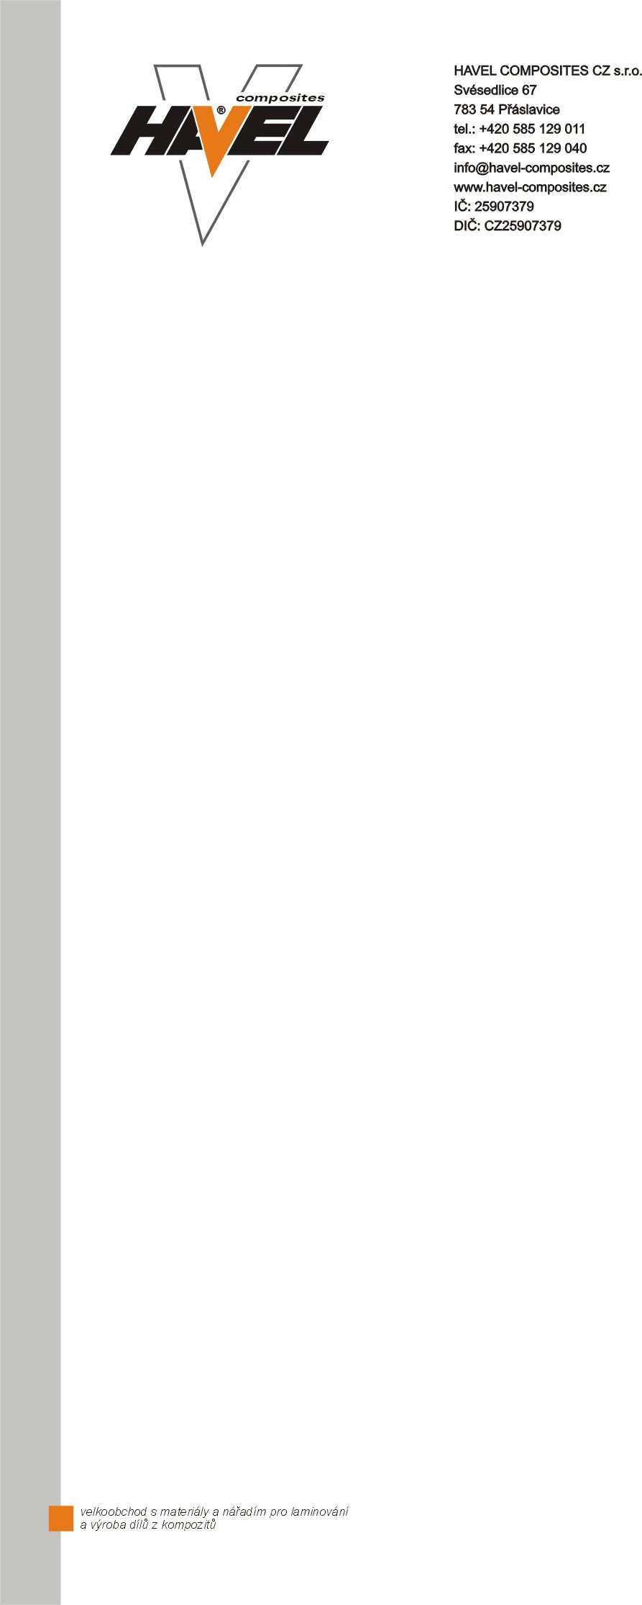

Mould resin P
- Hard elastic, good edge strength
- Excellent grinding and polishing properties
- Thixotropic (non-drip)
- Manufactured in a vacuum, so optimally free of air bubbles and homogeneous
This two-component epoxy resin is coloured black for gel coats in-mould construction with high edge strength and good polishing properties. Mould resin P is processed and cured at room temperature in conjunction with epoxy resin laminates and laminating ceramics. In contrast to resin and metal systems, the surfaces are polishable. This tooling gel coat is hard-elastic, i.e. not brittle, and exhibits good edge strength.
Consumption: approx. 0.6 kg/m² (thickness Ø 0.5 mm)
Hardener P-25
Hardener for Mould Resin P with a pot life of 20 minutes.
- Excellent chemical resistance (as far as possible styrene-resistant)
- Free of nonylphenol and benzyl alcohol
Mixing ratio: 100 : 25 parts by weight of resin to hardener
Processing time (100 g preparation at 20 °C): 20 minutes
Gel time (at 20 °C/1 mm layer thickness): approx. 2 hours
Curing time (at 23 °C): 24 hours
Temperature resistance: 70 °C
Processing instructions in GFK mould construction
Error-free application is possible on most release agents. If "eyes" should nevertheless form due to poor wetting of the substrate, a second layer of mould resin can be applied to the still sticky layer after gelation (several hours curing at room temperature). If two coats are applied, any imperfections are removed.
Procedure
1. apply mould resin with brush, layer thickness approx. 0.5 mm, allow to gel (approx. 2 h at room temperature)
2. if defects ("eyes") are formed due to the release agent, apply a second layer of mould resin, allow to gel
3. apply resin-rich coupling layer of laminating resin, glass fiber shavings + cotton flocks several mm thick
4. place glass fabric in the wet coupling layer and laminate on further layers of glass for reinforcement
Carry out all work wet-in-wet so that the layers adhere well to each other.
Other structures are of course possible. Depending on the size and geometry of the mould, other build-ups are possible:
- Laminate directly onto the mold resin, but starting with very fine fabric so that the structure does not push through.
- Laminate made of carbon fibre fabric, low mould weight, high rigidity.
- Laminate made of carbon fiber fabric and aramid honeycomb as intermediate layer, very low mould weight with high stiffness.
- Laminate made of laminating ceramics; fast assembly, very stiff, but also higher mould weight.
- Massive, stiff moulds made of mould resin with a thick-walled backing of resin and fillers such as sand, Poraver and similar.

Health and safety

Details on safety and health protection are given in the Safety Data Sheet of the product (MSDS) and labels of products.

Note for the reader

Havel Composites CZ s.r.o. (Havel) was convinced of the accuracy of the information provided at the time this material was prepared, or the information was taken from sources that the company believed to be reliable; however, the user is responsible for studying and understanding other relevant sources of information in such a way as to comply with all laws and procedures applicable to the safe handling and handling of the product and to determine the suitability of the product for its intended use. For all products supplied by Havel, Havel's sales terms and conditions apply. THE COMPANY MAKES NO WARRANTY, WHETHER EXPRESS OR IMPLIED, TO ANY PRODUCT OR ITS MERCHANTABILITY OR FITNESS FOR A PARTICULAR PURPOSE. HAVEL MAKES NO WARRANTY CONCERNING THE ACCURACY OF ANY INFORMATION CONTAINED BY HAVEL, except that its products will be in conformity with Havel's technical specifications. The information provided here does not constitute an offer for the sale of any product.

Created by: Ing. Richard Moravec At: 10.12.2020

