

Technical data sheet
CARBON ROVING HS230-3.5-4

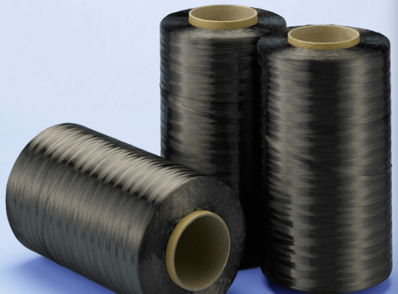

HS230-3.5-4 carbon fiber is a high-strength, high-modulus fiber made from polyacrylonitrile-based (PAN) carbon fiber precursor through high-temperature carbonization. The product has characteristics such as uniform linear density, high tensile strength and modulus with low dispersion, good resin composite performance, minimal fuzziness, and good fiber spreading performance.

Fiber  specification | Product grade | Linear  Density | Volume  density | Tensile  strength | Tensile  modulus | Rupture  elongation | Carbon  content | Sizing
Fiber  specification | Product grade | g/km | g/cm3 | GPa | GPa | % | % | %
HS230-3.5-4 | 12K | 800±20 | 1.78 | 3.5~<4.0 | ≥230 | ≥1.5 | ≥93 | 1.1
HS230-3.5-4 | 24K | 1600±40 | 1.78 | 3.5~<4.0 | ≥230 | ≥1.5 | ≥93 | 1.1
HS230-3.5-4 | 48K | 3700±100 | 1.78 | 3.5~<4.0 | ≥230 | ≥1.5 | ≥93 | 1.1

Standard packaging specifications:
12K/24K – 4kg/ bobbin 24kg/carton
48K – 4, 8, and 10kg/bobbin 24-30kg/carton

February 2024
Havel Composites CZ , s.r.o.,Svésedlice 67,Přáslavice,783 54
Phone: +420585129011
www.havel-composites.com, info@havel-composites.com

